Pogipedia Documentation – 5/13/2026
Carter Quickel

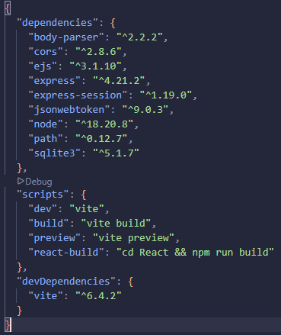
Below is the necessary information that can be used to start back up on the website. This website uses React for its UI, which must be built to generate the website.
To update the React after edits are made, use the command:
npm run react-build
After this is complete, you can run node app to see your changes.
Begin by creating a new fork of Pogipedia, and when creating pull requests, make the pull request to csmith’s main.
To get started on this project, npm install all the necessary packages. Check the default package-json above or in the vscode. There are folders containing pog images, icons, index, etc. The database is the new method of adding pogs. THE CSV FILE IS OUTDATED.
The GitHub repo shows the issues that need to be worked on. From there, anything else can be added. If the React content needs adjusting to improve work efficiency, do so as necessary.

Things included:
- Pagination of pogs that are fetched from the pog database.
- A fully customizable React DOM that can be accessed by future company employees.
- Editable descriptions of the pogs that can be edited by me and Mr. Smith. To edit these admin privileges, add your name to the list of admins in the .tsx.
- A working filter system that can get pog tags and rarities.
- Viewable pogs with all their attributes.
- Pog-flipping to see the pog's ID.
Things needed:
- The title, creator, color (anything on the view of the pog) needs to also be editable, not just description.
- Any more future updates.
Things required to work on this project:
- High React experience.
- JavaScript experience (minimal).
- High CSS experience.
